Day 14
Task 1:
Git collaboration is the process of multiple developers working together on the same codebase using Git, a distributed version control system. It allows team members to make changes independently, track revisions, and merge their work without overwriting each other's changes.
Task 2:
Collaboration is necessary in Git because most software projects are developed by multiple people at the same time. Git provides a structured way for team members to work on different parts of a project, track changes, and combine their work safely.
Task 3:
- git clone <repository-URL>: Creates a local copy of a remote repository on your machine.
- git status: Shows the current state of your working directory and staged changes.
- git branch <branch-name>: Creates a new branch for separate development work.
- git checkout <branch-name>: Switches from the current branch to another branch.
- git switch <branch-name>: Switches to an existing branch using the newer Git command.
- git add <filename>: Adds a specific file to the staging area before committing.
- git add.: Adds all modified and new files to the staging area.
- git commit -m "message": Saves the staged changes in the local repository with a description.
- git push origin <branch-name>: Uploads local commits to the remote repository.
- git fetch origin: Downloads the latest changes from the remote repository without merging them.
- git pull origin <branch-name>: Downloads and merges the latest changes from the remote repository.
- git merge <branch-name>: Combines changes from one branch into the current branch.
- git log: Displays the complete history of commits in the repository.

Task 4:
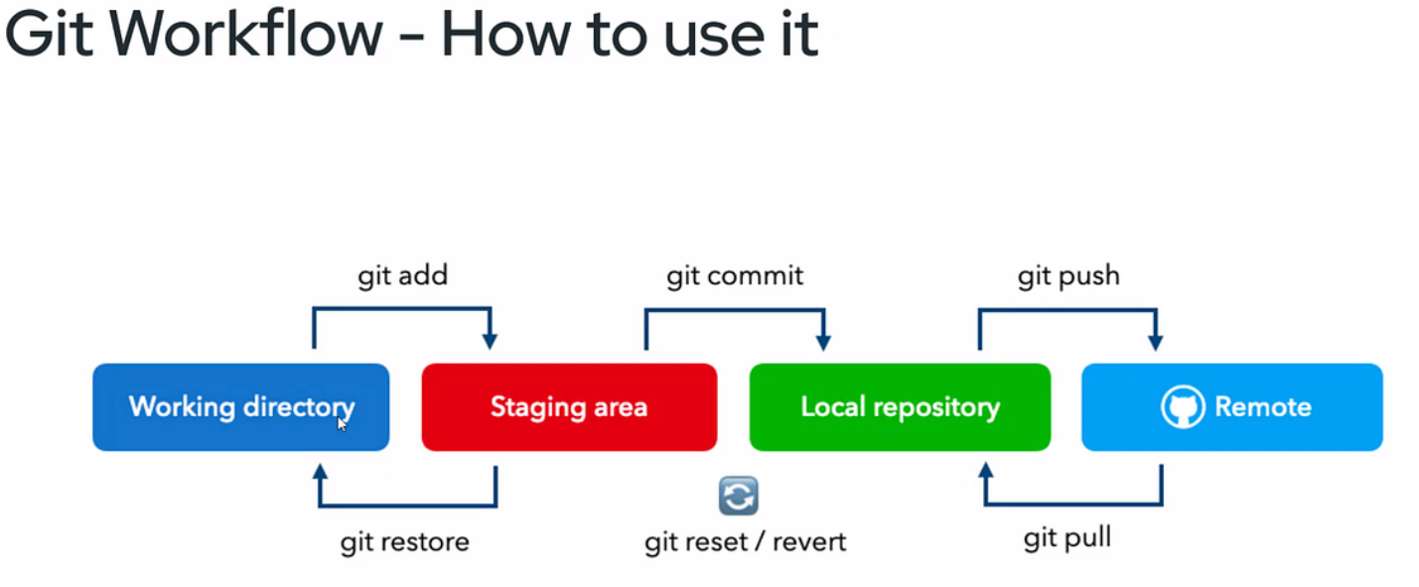
Task 5:
- Pull latest code daily: Always pull the latest changes from the repository before starting your work.
- Use feature branches: Always work on a separate branch instead of directly on the main branch.
- Commit frequently: Make small and logical commits to keep changes easy to track.
- Write meaningful commit messages: Use clear commit messages that describe the purpose of the change.
- Review changes before committing: Check your modifications to avoid committing unwanted changes.
- Push code regularly: Push your commits frequently to keep the remote repository updated.
- Resolve conflicts promptly: Address merge conflicts as soon as they occur.
- Create Pull Requests: Submit a Pull Request before merging code into shared branches.
- Run tests before pushing: Ensure the code works correctly before sharing it with the team.
- Avoid committing sensitive data: Never commit passwords, tokens, or confidential information.
- Delete unused branches: Remove branches that are no longer needed after merging.
- Follow naming conventions: Use consistent branch names to improve repository organization.
Task 6 – 9:
(GitHub)
Task 10:
- Primitive data types are basic data types like string, number, and Boolean that store simple values.
- Special data types are types like any, unknown, void, null, undefined, and never that are used for special programming situations.

Task 12:
- First, install Node.js on your system because TypeScript requires Node.js to execute JavaScript files.
- Next, install TypeScript globally by running the command (npm install -g typescript).
- After installation, verify that TypeScript is installed correctly by using the command (tsc -v).
- Create a new file with the .ts extension, such as (demo.ts).
- Write your TypeScript code inside the file and save it.
- Open Command Prompt and navigate to the folder where the TypeScript file is located.
- Compile the TypeScript file by running the command (tsc demo.ts).
- The TypeScript compiler converts the file into a JavaScript file named demo.js.
- Verify that the demo.js file has been generated in the same folder.
- Run the JavaScript file using the command node demo.js.
- Finally, view the output displayed in the Command Prompt.
Task 14:
Type annotations in TypeScript are used to explicitly specify the data type of a variable, function parameter, or return value.
Task 15:
The any keyword in TypeScript is used when a variable can hold values of any data type, and TypeScript will not perform type checking on that variable.
Task 16:
The any type allows you to use any operation without checks, while the unknown type requires you to check the data type before using it.
Eg –
let a: any = "Hello";
console.log(a.toUpperCase()); // Works

let b: unknown = "Hello";

// console.log(b.toUpperCase()); // Error

if (typeof b === "string") {
console.log(b.toUpperCase()); // Works
}

Task 17:
The tsconfig.json file is used to configure how the TypeScript compiler (tsc) compiles TypeScript code into JavaScript.

